Microsoft Portal Login: https://portal.azure.com/#home
Username- ankesh.shahi@miritech.com
Password- miritech@123
Step 1: Click on “Resource Groups” and then click on”Add” as shown in the screen below:
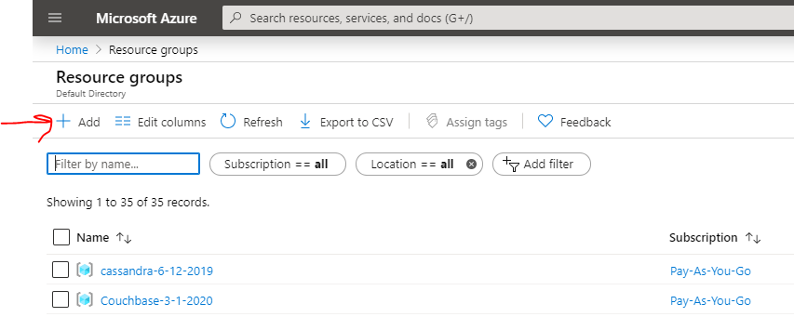Note- The special care of the naming conventions. It should be like:
wordpress-16-01-2020 – (name of the product followed by the present date)
Subscription- pay-as-you-go
Region- either select East US or East US 2
Tags- Leave blank
Click create.
Step 2: Click on “Virtual Machines” as shown below:
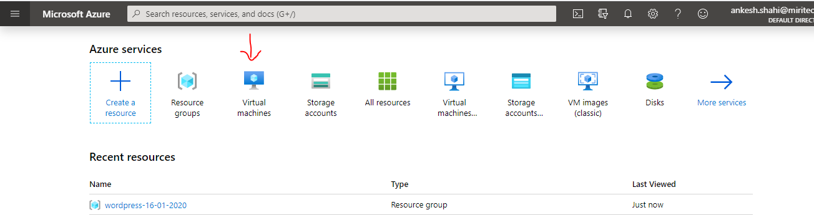
Click on “Add” as shown:
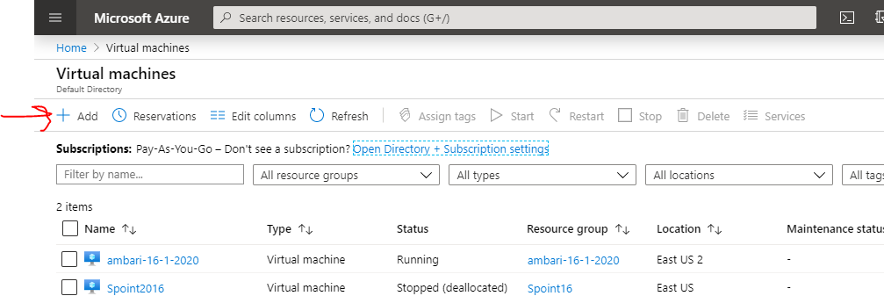
Now, select the “resource Group” initially created by the name- wordpress-16-01-2020
Virtual machine name- wordpress-16-01-2020
Region- as selected before- (US) East US 2
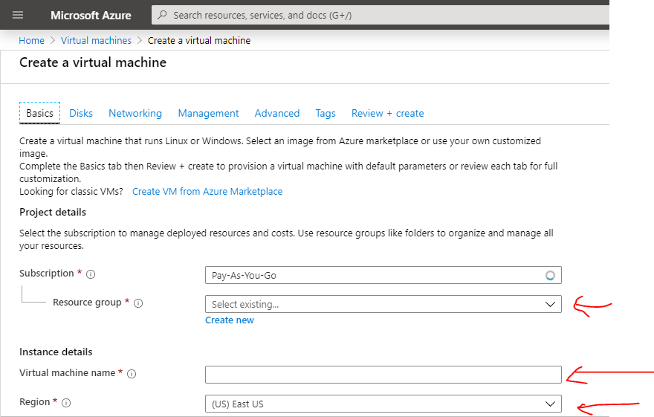
After that, select the size of the machine, the lowest one.
Then enter the username as the name of the product, e.g., wordpress
Password- miri@12345678
Note- password would be same for every product.
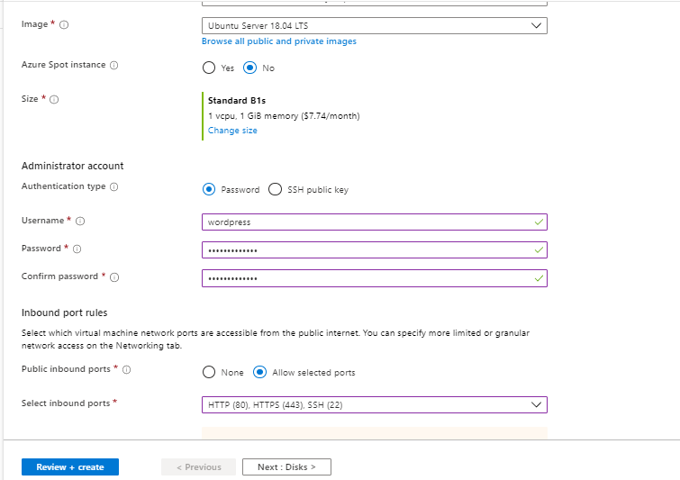
Also select all the ports there itself and click on “Next”.
Step 3: Now, in this section, always select the “Premium Disks”. Now click on the “Advanced Settings” and under the section “use managed disks”- select “No”.
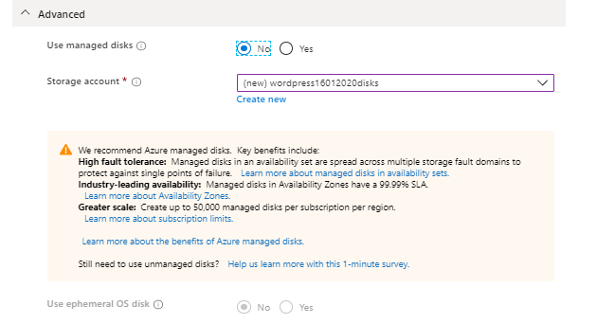
Step 4: click on “next”. No change is required in this section.
Step 5: Click on “Next”. And select the option of “Boot diagnostics” as “Off” as shown in the fig:
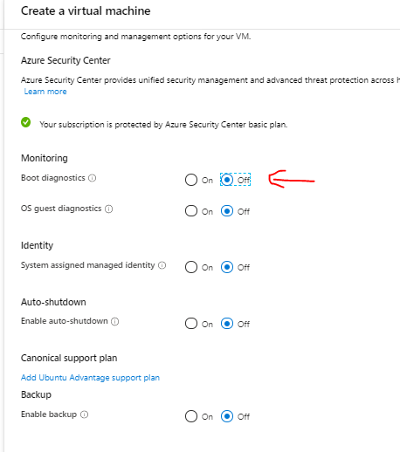
Step 6: click on “next”. No change is required in this section.
Step 7: click on next and leave blank the tags section.
Step 8: click on “Create”
Note- the machine would take some time to get ready.
Step 9: you will get a notification that “YOUR DEPLOYMENT IS READY” AND AFTER THAT THERE ITSELF, CLICK ON “GO TO YOUR RESOURCE GROUP” as shown below:
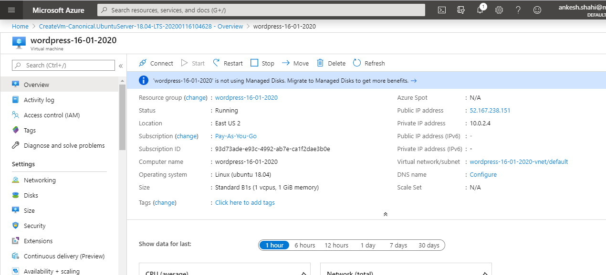
Step 10: Now from here, click on the “Public IP address:”, copy that ip.
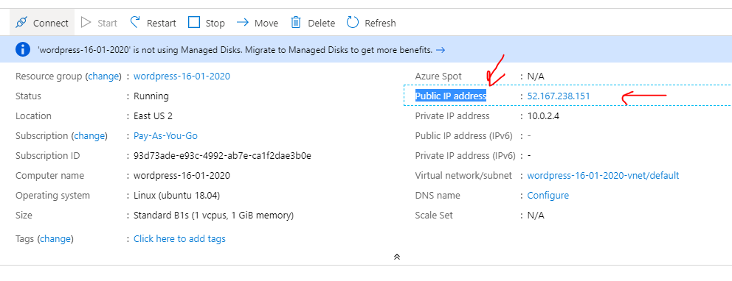
Step 11: after copying that ip, open your “Putty” and paste the ip over there as shown below:
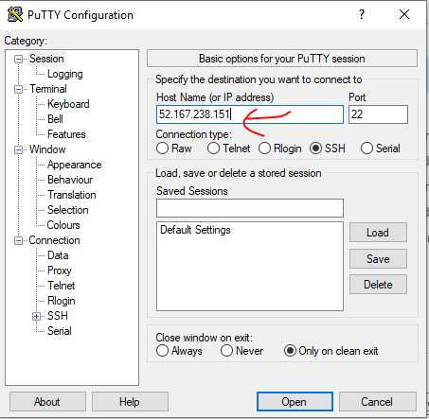
And click on open.
Step 12: a window will appear and you have to click on “yes”
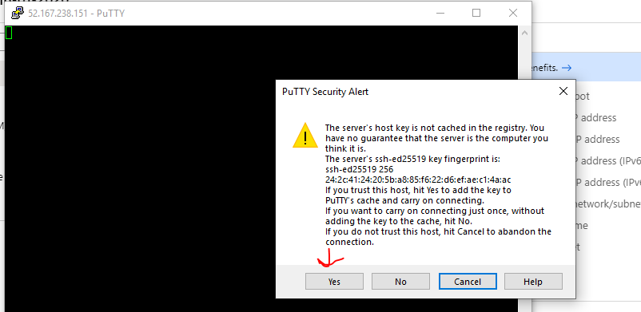
After clicking on yes, enter the
Login as- wordpress, password- miri@12345678
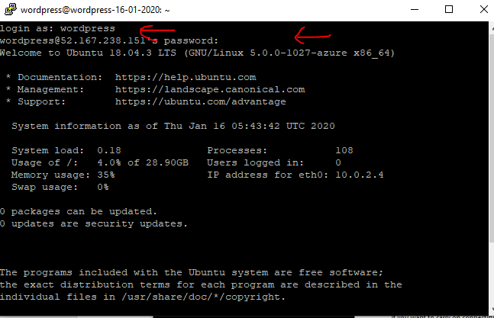
Step 13: after that, please start with “sudo su”
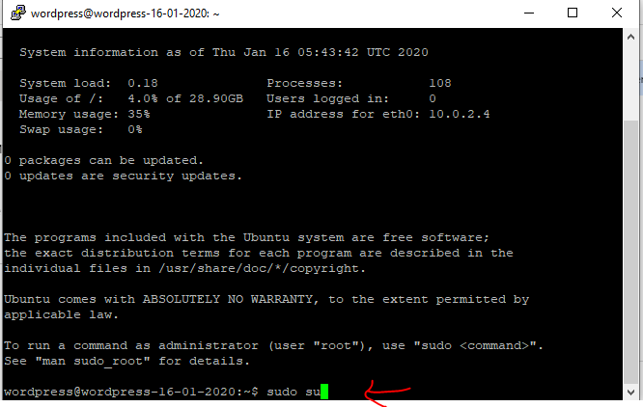
And then you can start creating your product.
You can google the product you want to create as: wordpress install Ubuntu and then you can follow the appropriate installation guide, follow those steps
Example- 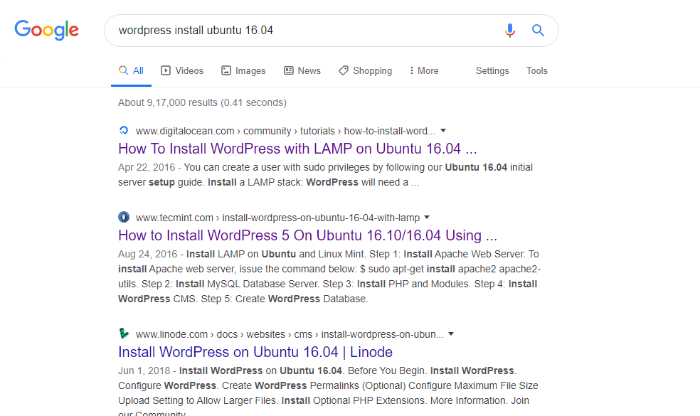
You can follow the tutorials.
After you have finished with your commands on linux, please copy your “Public IP” and fire it on the browser to check if your product is working or not.
Once your product is working, you need to follow few steps as shown below on your virtual machine:
- history -c
- sudo apt-get update
- sudo apt-get install walinuxagent
Once done, you need to download two tools on your system.
Certification Tool for Microsoft Azure- https://support.microsoft.com/en-in/help/2977336/configure-an-azure-management-certificate-so-that-microsoft-virtual-ma
Storage Account- https://azure.microsoft.com/en-us/features/storage-explorer/
After that, once your certification tool is downloaded, open that and paste your ip address and name of the product that you are making.
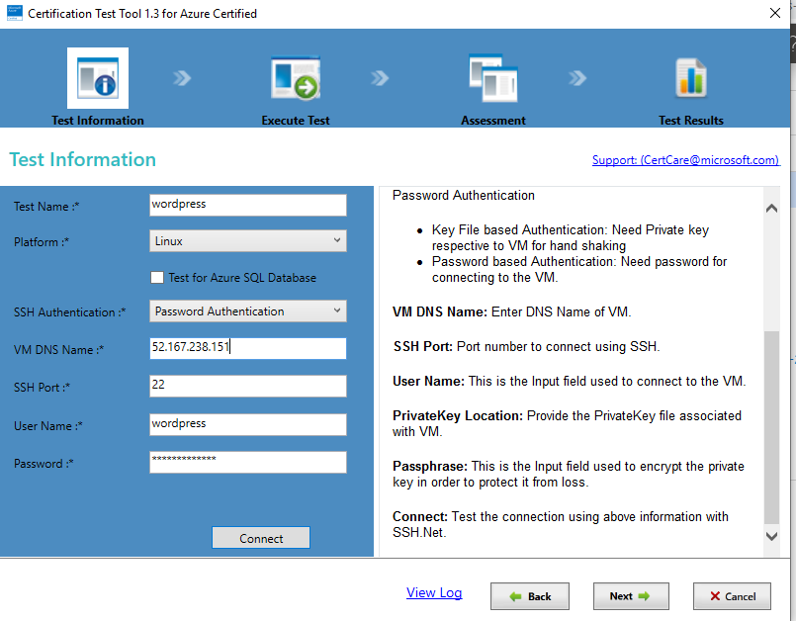
And click on connect to check if the connection is established or not. Click on next.
The next screen would be something like this as shown:
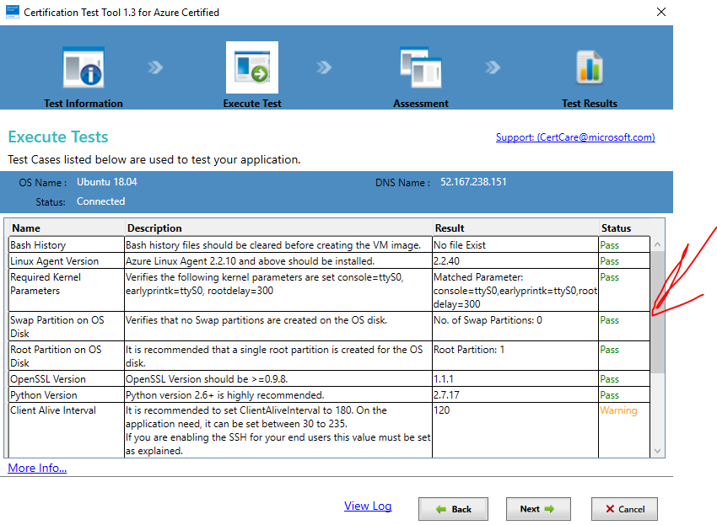
Check for the “pass” status and click “next”.
Click on True and then click next
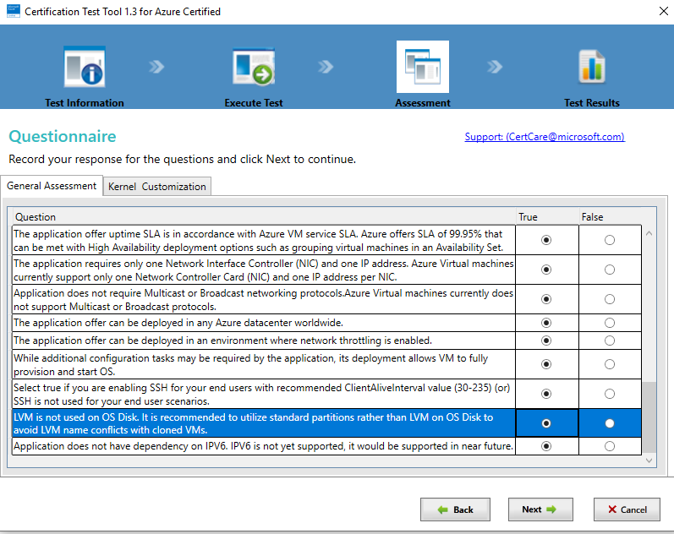
Select all the drop downs as “No”
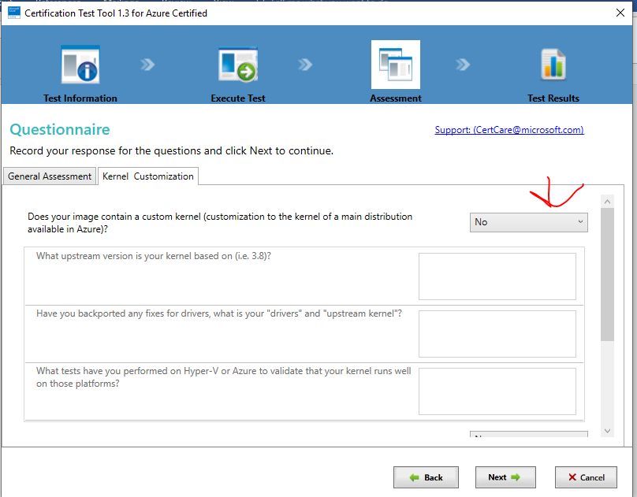
Click next.
Now, click on generate report and exit
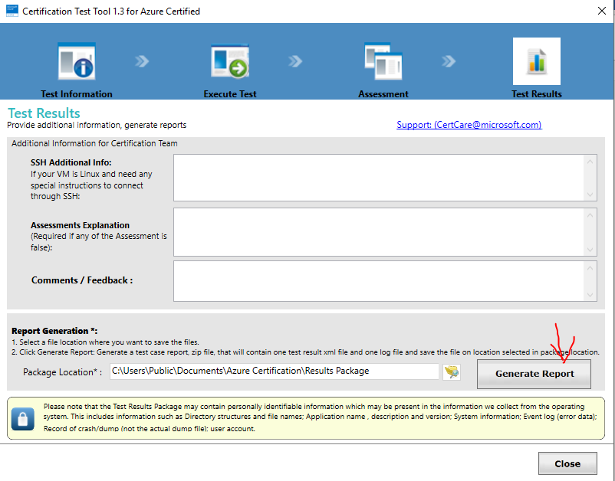
Your zip file would be generated. And then close.
Step 14: now enter the following command in your putty.
waagent -deprovision+user –force
Step 15: After doing this, open your “Command Prompt” and enter the following commands there:
az login
Note- it will login you to the azure portal. After that execute the following commands on cmd to create image.
az vm deallocate --resource-group myResourceGroup --name myVM
az vm generalize --resource-group myResourceGroup --name myVM
az image create --resource-group myResourceGroup --name myImage --source myVM
Note- now your image is created. After that, please delete all the resources from resource group except the Storage Account and Image.

Steps to publish your product to marketplace:
Login on the link: https://cloudpartner.azure.com/

- Click on new offer-> virtual Machines
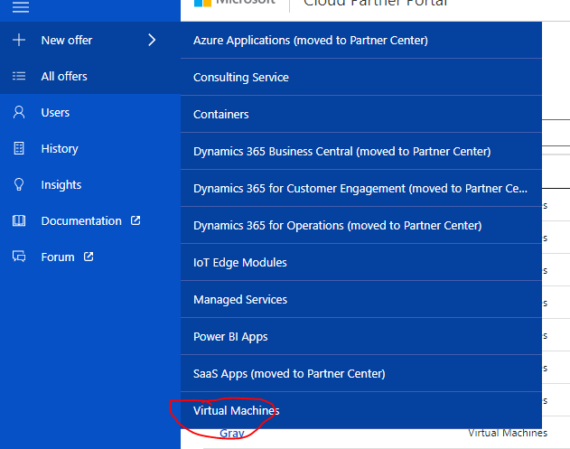

Enter the details accordingly as shown in screenshots below:

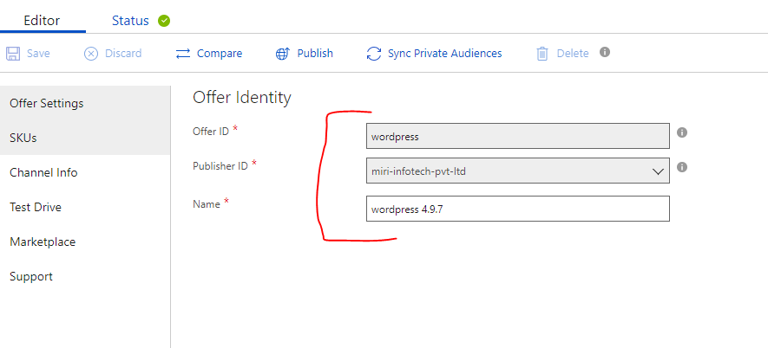
- Click on SKUs and click on new SKU:
Enter the details accordingly:
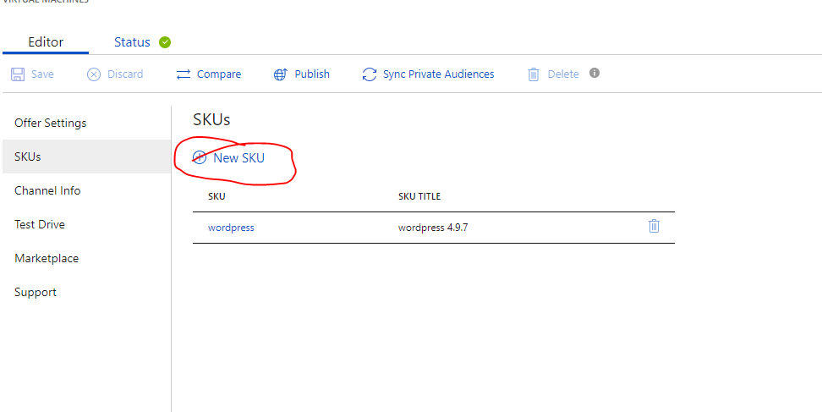
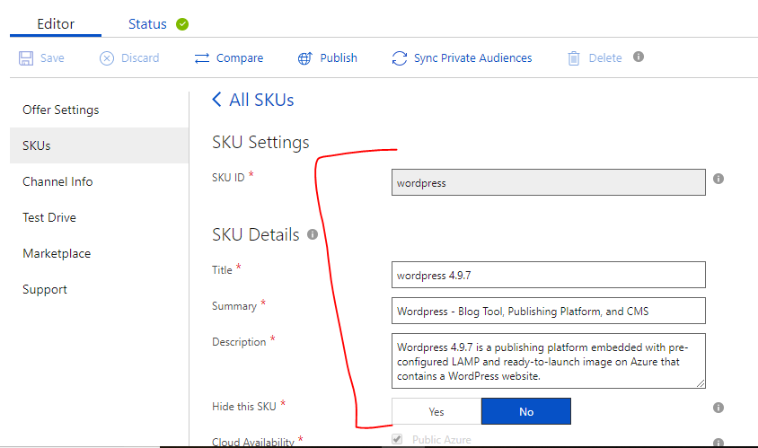
- Please select all the regions accept china.
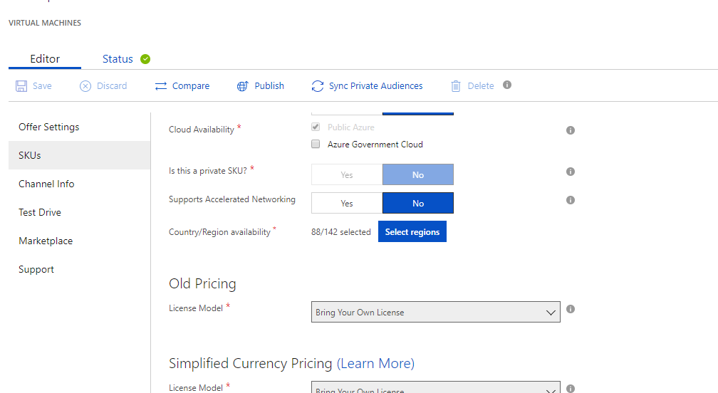
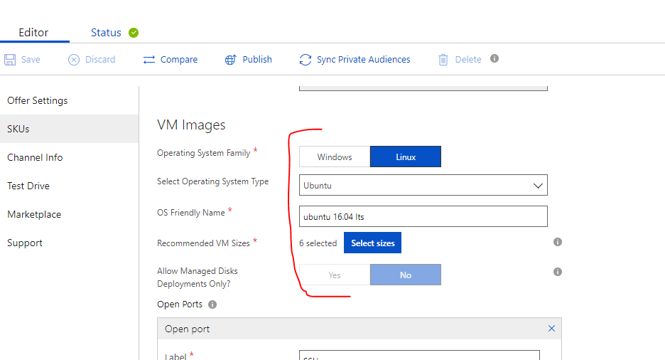
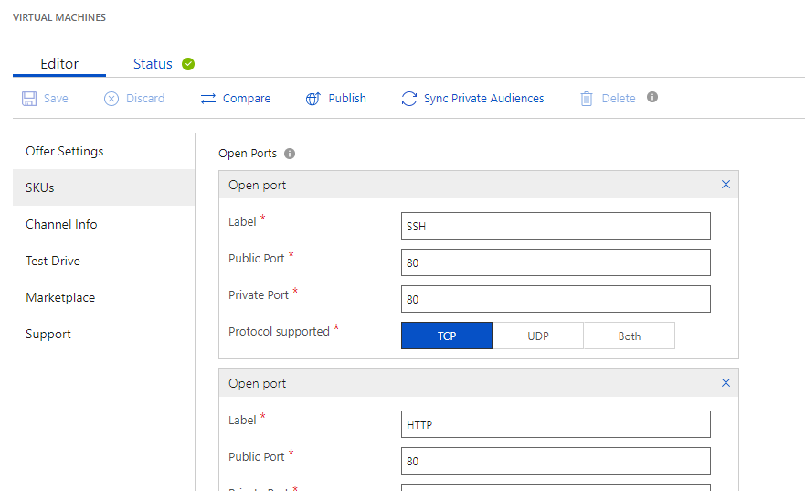
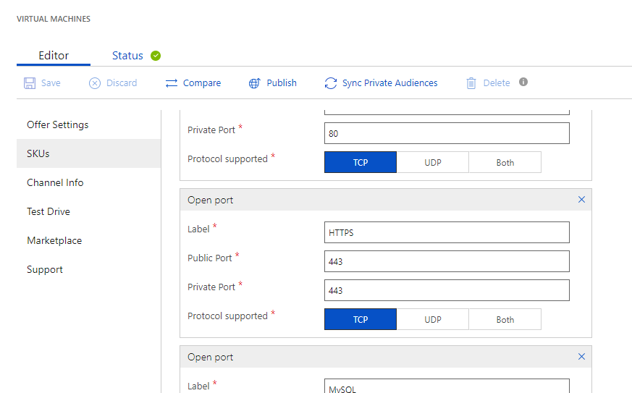
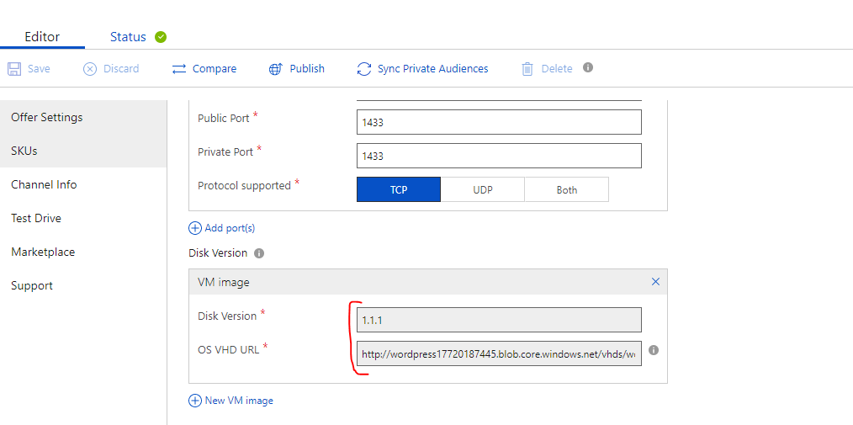
Note: steps to generate the OS VHD URL can be explained verbally.

- Leave blank the Channel info:
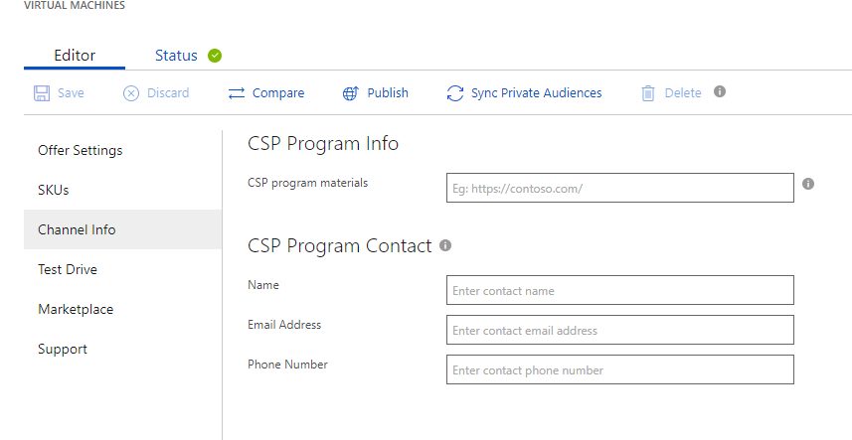
- Leave no to test drive:
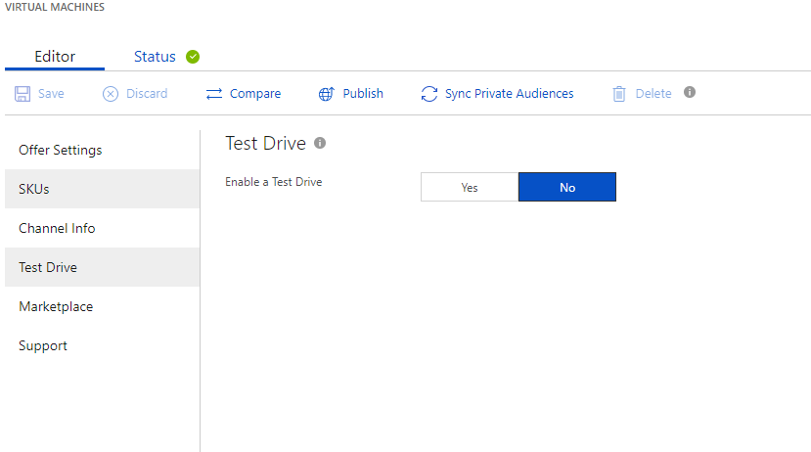
Enter the details accordingly and remember to add the lead management as “salesforce” and token as 00D6g000002guNv

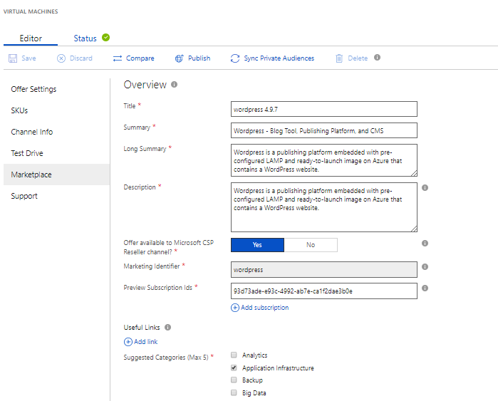
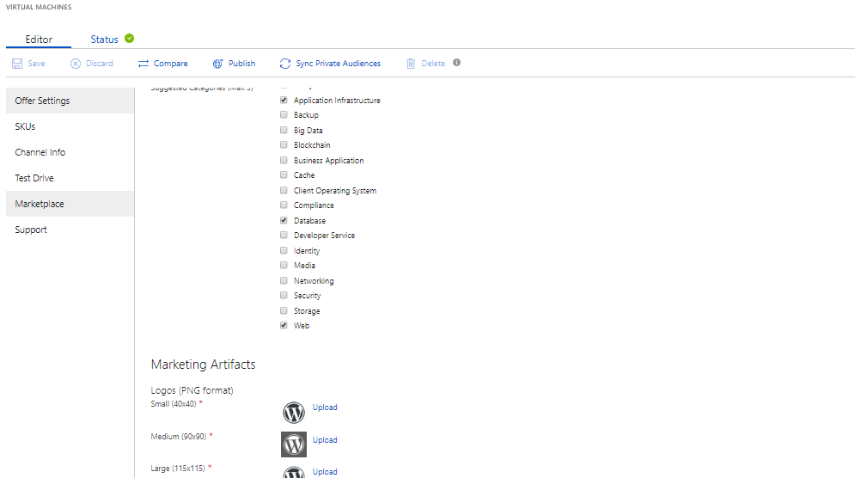
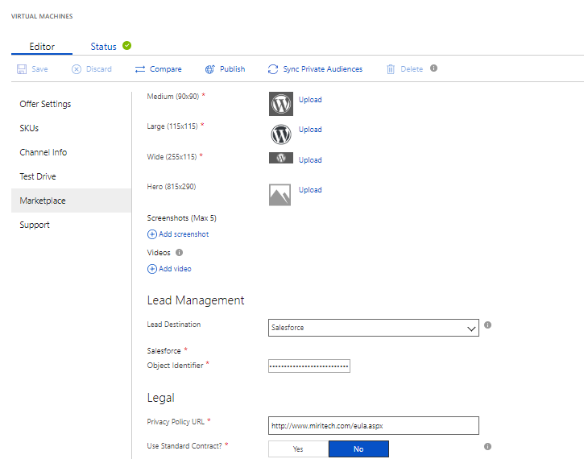
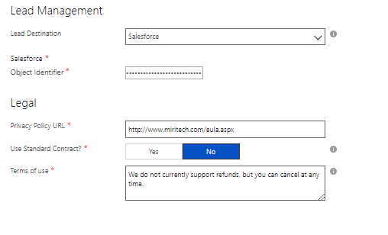
- Enter the details as shown below:
